NEXT JS
Why NextJS ???
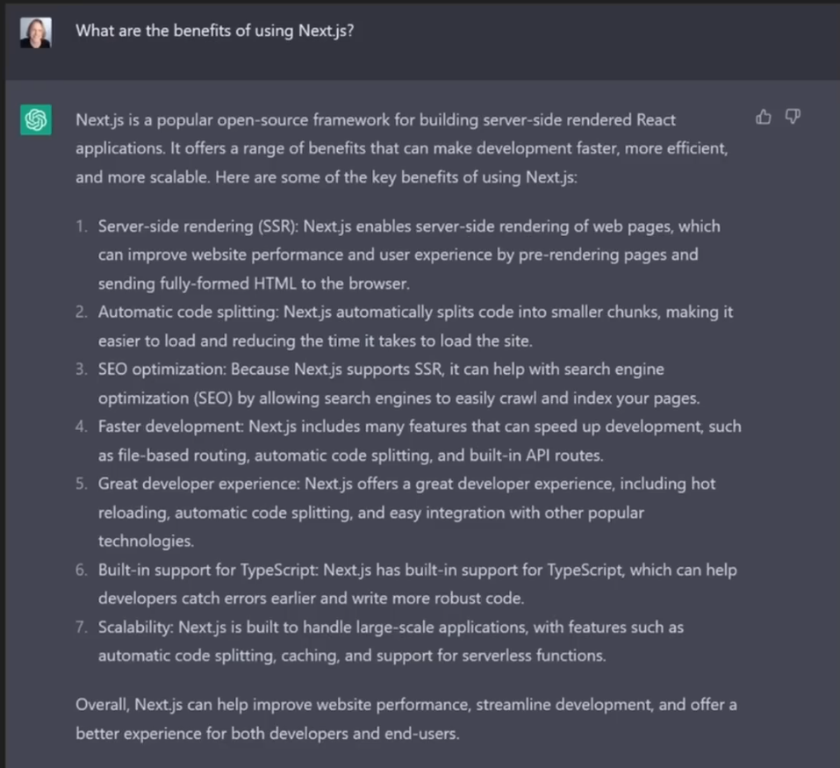
NOTE
ALL COMPONENTS IN NEXTJS ARE SERVER BY DEFAULT UNTIL YOU USE - “use client”
So Profiler cant record anything

How Next js works
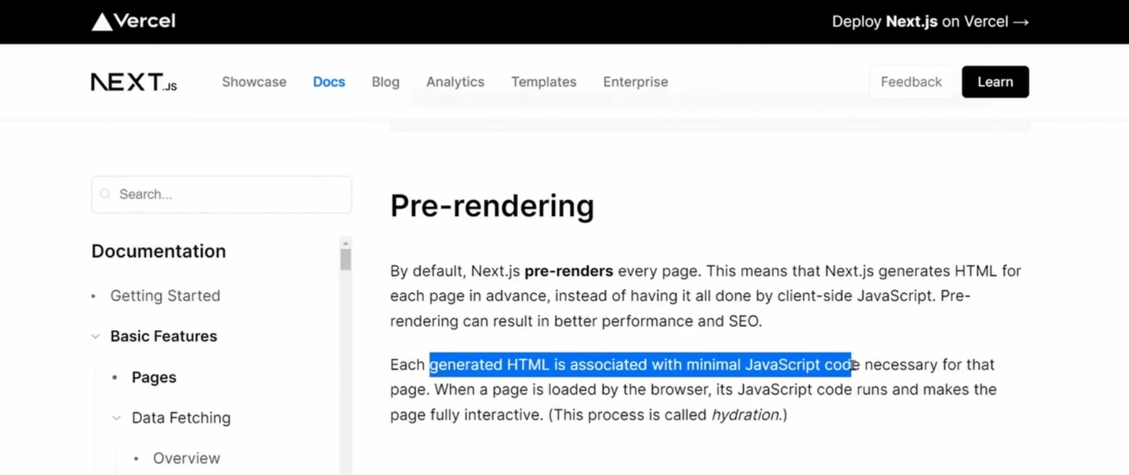
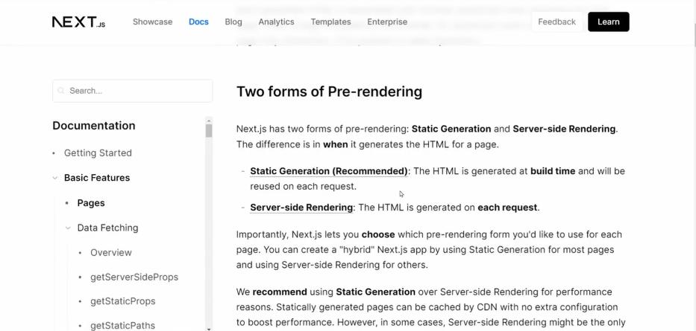
Now by default NextJS Prerenders Everything instead of sending a bundle of Javascript to the browser. Resulting to Not Only Better performance but also better Seach Engine Optimization
Each generated HTML is associated with minimal Javascript code necessary for that page And when the page is loaded by the browser, Its Javascript code runs and makes the page fully interactive (And The Process is called HYDRATION)
And there are Two Forms of Pre-rendering
- Static Generation(Recommended) – HTML Is Generated at Build Time and will be reused on each request
Content Derivery Network (CDN) – Because if we are generating our sites static they can be cached in Different Servers and ready to serve more faster (Leading to Faster Load)
- Server side Rendering – The HTML is generated on each request
How ever both of these can be combined with client side Data fetching
Server Side Rendering helps in SEO issues
Now How CDN Works
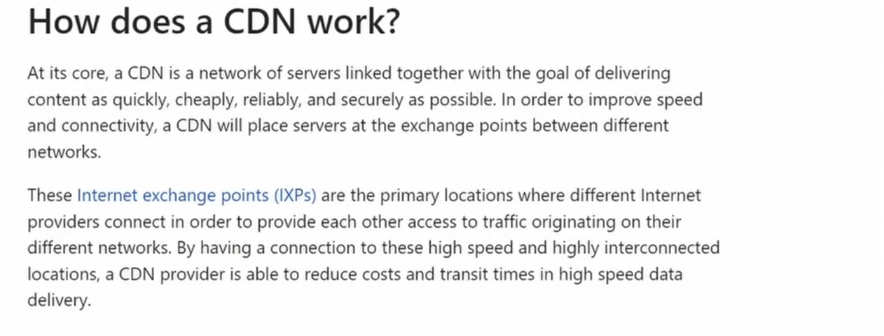
So if we generate our site statically our sites can be cached at these different servers and ready to server faster

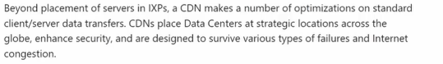
Now After All the NextJS Concepts and the Folder Structure Lets Start with One step after another
PAGES & LAYOUTS
SEO & Metadata Am not going to use head component
Now for the error boundary is it doesn’t crash the whole project just a page with error
But Now Is By DEFAULT in the NextJS 16 so we don’t need an error component
Their Components are server by default
FETCH DATA
Next JS Released 13.2 so lets first take a look at the metadata update before we start with fetch
Data Fundamentals

Here's a quick overview of the recommendations on this page:

1. Fetch data on the server using Server Components.

2. Fetch data in parallel to minimize waterfalls and reduce loading times.

3. For Layouts and Pages, fetch data where it's used. Next.js will automatically deduplicate
requests in a tree.

4. Use Loading UI, Streaming and Suspense to progressively render a page and show a
result to the user while the rest of the content loads.

To fetch Data in Next JS you just need to make the async function then await

